Project Proposal Report

on Developing a Mobile Application

for Stage 1 Alzheimer’s Disease Patients

|  |  |
| --- | --- |
| Team | Contribution |
| Anthony Gramaje | Introduction, Background, Reference, Document Finalization |
| Nandini Mulay | Literature review of mobile applications, Reference |
| Purvang Singwala | Mobile app development, Reference, Risks and Limitations |
| Heman Patel | Mobile app development, Reference, Risks and Limitations |

Table of Contents

Title Page …………………………………………………………………………………………………………………… 1

Team Contribution …………………………………………………………………………………………………….. 2

Table of Contents ……………………………………………………………………………………………………….. 3

Chapter 1: Introduction……………………………………………………………………………………………….. 4 - 7

Chapter 2: Current Solution……………………………………………………………………………………….. 8 - 10

Chapter 3: Problem Identification…………………………………………………………………………….. 11

Chapter 4: Software Methodology Followed…………………………………………………………….. 12

Chapter 5: Risks and Limitations ……………………………………………………………………………….. 13

Chapter 6: References……………………………………………………………………………………………….. 14

Chapter 1: Introduction

**1.1. Background**

Alzheimer’s Disease has been around for more than a century since it was discovered by Alois Alzheimer in 1906. Alzheimer’s initial encounter of this perplexing illness occurred during the admission of his patient Auguste D in 1901 at the psychiatric institution in Frankfurt Germany. Auguste has shown signs of forgetfulness, responding unintelligently when questioned during interviews and demonstrating odd behaviors. Her symptoms made Alzheimer keen to conduct further his clinical investigation of her situation. When Auguste D died on April 08, 1906, her brain was clinically examined by Alzheimer. He discovered 3 things during the pathological examination. First, there was a huge reduction of the volume of neurons. Second, there were visible tangles and third, accumulation of plaques. These findings were presented on November 03, 1906 at the 37th meeting of Southwest German Psychiatrists in Tubingen Germany (Dahm, 2006).

Alzheimer’s Disease is an illness related to the death of neurons in the brain. It is characterized by clinical symptoms and biological changes in the brain and one of the leading causes of Dementia. Clinical symptoms are referred to memory weakening, inability to convey messages verbal and non-verbal, deteriorating intellectual capacity, incompetence to self-care, diminishing capacity of the body to be used in full range and loss of senses (Chin & Tay, 2018). The culprit of biological changes in the brain is caused by four pathological processes. The first one is Mitochondrial dysfunction. Due to oxidative stress production, it creates a damaging influence on a cellular function which reduces the cell’s energy metabolism. The second cause is the increased presence of Amyloid beta protein and tau protein. The abnormal deposits blocks and stops the natural flow of communication of the neurons within the brain. The third is the oxidation which is responsible for damaging the integrity of the cells and its physiologic function. Lastly is the neuroinflammation. The conversion of brain cells from anti-inflammatory to inflammatory produces destructive inflammatory processes resulting to the death of neurons (Weinstein, 2018)

The way Alzheimer’s Disease develops is not overnight. It takes years to reach the terminal stage. Some refer to it as slow goodbye. The symptomatic changes of the person whether it is the memory loss or behaviour are not sudden however, it becomes obvious as time goes by. It lasts for about 8 to 20 years based on the health status of the patient. The patient dies predominantly not due to Alzheimer’s but because of the associated other health problems like pneumonia, kidney failure, heart disease, other infections, and even cancer. Alzheimer’s Disease has 3 stages: Early-to-Mild, Moderate and Severe. Each has its own unique manifestation of changes and behavior (Callone, Kudlacek, Vasilof, Manternach, & Brumback, 2006).

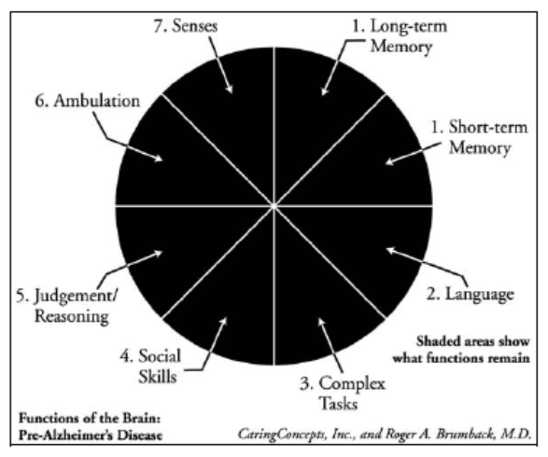Figure 1 shows the functions of the brain without the presence of Alzheimer’s Disease. A healthy brain has all 7 functions working effectively. Long-term and short-term memory can recall clearly the processes, tasks, people, and objects. Newly acquired skills are retainable and can successfully perform duties by using the most efficient way of using past and present experiences. The brain can understand language whether it is verbal and non-verbal and even if it is expressed idiomatically. Healthy brain can send signal to remind the person to be aware of personal hygiene and avoid any hazards. A normal brain has the ability to interact with other people properly using words that are appropriate. A healthy brain can appropriately use all the parts of the body for movement like playing drums, boxing, and other activities that are physically dominant in nature without signs of confusion. Lastly, a healthy brain can use all the senses especially the need of intimacy (Callone, Kudlacek, Vasilof, Manternach, & Brumback, 2006).

Fig. 1 *A healthy brain without Alzheimer’s Disease*

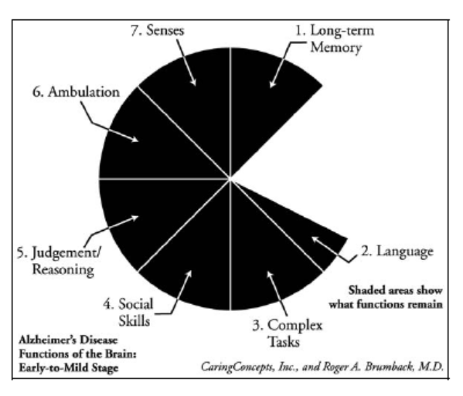Figure 2 shows the stage 1 of the disease and how short-term memory has completely gone and language has a smaller share of the pie. The first area to be damaged, because of the progression, is the short-term memory. At this stage, the patient is still aware about his situation and coping up the loss by having a memory aide like signs, reminders, pictures, labels and markings all over the place. Communication is problematic and caregiver is expected to make the communication as simple as possible. Tasks are still possible to be delegated to the Alzheimer patient. At this point, tasks should be dissected and in granular form. Invited friends and relatives are of great advantage to accommodate social need. It is desirable to get the patient involve in legal and financial matters during this stage because the judgement and reasoning is still intact. The patient can specify exactly how future needs should be and other legal matters. The part of the brain responsible for movement is still in full capacity. The patient can enjoy independence of movement and still able to contribute for most of the tasks especially at home but within the limits of safety. Senses are unharmed at this point and patients are able to use all the senses like hearing, seeing, feeling, smelling and taste (Callone, Kudlacek, Vasilof, Manternach, & Brumback, 2006).

Fig. 1 *Stage 1 Alzheimer’s Disease*

**1.2. Scope**

The scope of this project is to build a mobile application that will serve as a memory aide for stage 1 Alzheimer’s Disease patients. This will contain granular form of tasks that will help to schedule tasks according to the pace and remaining skills of the patient. The tasks are not specific to gender or age. The application is built using java programming language that runs on a Android type mobile devices such as tablets and mobile phones.

**1.3. Aim**

The goal of this project is build a working prototype that has the functionalities simple enough to accommodate the needs of the stage 1 Alzheimer’s Disease patients which can be also demonstrated in the class. The goal of this project is to build a mobile application that will serve as a memory aide for stage 1 Alzheimer’s Disease patients. This will contain granular form of tasks that will help to schedule tasks according to the pace and remaining skills of the patient.

**Chapter 2: Current Solutions**

**2.1. Alzheimer Master**

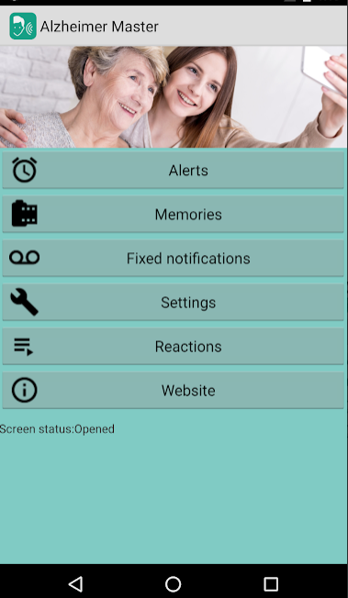Alzheimers Master is an android mobile application designed for patients diagnosed with Alzheimer’s to remind them of their day-to-day activities, which the caregiver can keep a track off. Daily or weekly notifications can be set, where the user or the caregiver can record their own voice recording as a reminder notification instead of a computerised autogenerated voice. Under the Memories tab, new music, videos and pictures can be added to enhance the mood of the patient. The reactions generated after seeing the notifications and memories can be automatically captured through voice recording, which can be checked by the caregiver to analyse the behaviour of the patient. With the use of an android smart watch, the application senses when the patient wakes up in the middle of the night and can thus update the patient’s whereabouts by playing a pre-recorded voice message and can also illuminate the room. With the help of door sensors, the application is developing a home-leaving notification feature, where on opening the entrance door of the house the application plays a reminder for the patient to carry his/her phone, which indeed will help the caregiver to trace the patient’s location. The settings option can be secured with a password by

Fig. 3 *Alzheimer Master app*

the caregiver, disabling the patient to modify. Under the free version, the user can only set one notification and one upload under memories tab and check the functionality of the application. The paid version cost $22.99 which gives unlimited access to notifications, memories and the awakening feature, plus the home-leaving notification feature will be included which is yet under development. (Alzheimer Master Team, 2018)

**2.2. Memory Helper**

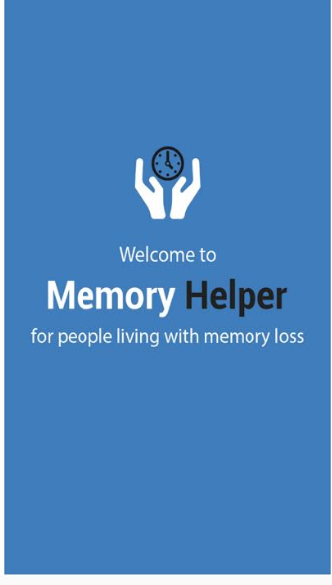Memory Helper application is a verbal transmission tool for Alzheimer’s/dementia patients which facilitates easy communication between the care giver and the care receiver, this application is available for iOS and android users. The simplicity and no interaction needed from the care receivers end are the highlights of the application. The caregiver can operate the Memory Helper APP through smartphone/tablet/laptop to setup daily activities which will be directly reflected on the care receiver’s tablet. Calendar clock, diary, reminders and instant messages are the 4 main functionalities. Memory Helper in the form of tablet device is placed securely on a stand, in the frequently visited areas of the care receiver’s house, thus just a glance and no other interaction is required from the receiver’s end. To receive instant updates via carers Memory Helper app, the receiver’s tablet should be connected to WIFI/internet. Sound alert notifications are sent to receivers’ device whenever there is a new entry plus all the updates are being instantly reflected on the receiver’s device. The application can be installed in several devices and the same information will be synced in all. Numerous carers can operate care receiver’s device. The application is available for 7-day free trial post that monthly chargers of $9.99 is applicable. (Memory Helper Carer Assistance Tool, 2018)

Fig. 4 *Memory Helper app*

**2.3. AMOM-Elderly Alzheimer Dementia Daily Assistant**

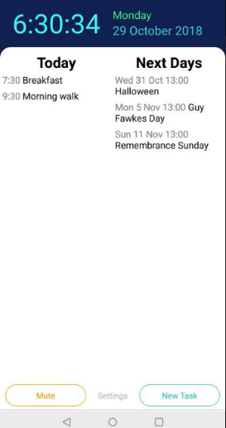 The main objective of Andre Reis the AMOM-Elderly Alzheimer Dementia daily assistant application developer, is to constantly remind the patient of their daily activities, to inculcate a habit which is beneficial in long run. The caregiver or the user can set repetitive routine/occasional task reminders (like drink water, seat for a while) in the form of text and even by recording their own voice which will be notified in intervals as per the duration set by the user. User/caregiver can mute the reminder for a specified time frame, example between 10 pm to 6 am while the patient is sleeping. User can manage and see the task from google calendar which can be synced in the application. This application is free of cost and can be downloaded from GOOGLE PLAY STORE. (AMOM,2018)

Fig. 5 *AMOM-Elderly Alzheimer Dementia Daily Assistant app*

**2.4. Dementia Digital Diary Clock**

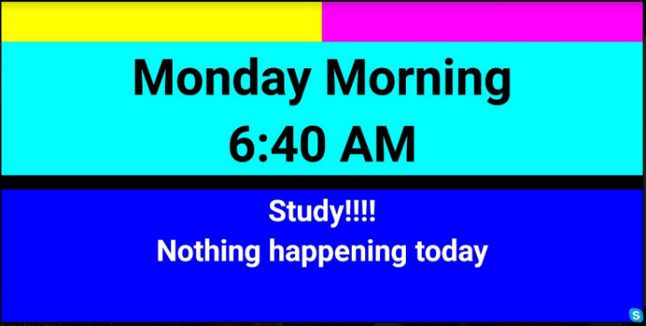Dementia/Digital Diary/Clock concentrates on being a simple visualization tool with a clock and calendar events on the application screen. Digital/analog clock, 12/24-hour time mode, text available only in uppercase, reduces the screen brightness at night, day of the week are options available for the display on screen. Android and iOS calendars can be synced with the application enabling the display of daily events. Visual alerts can be acknowledged and the screen colour can be adjusted to stimulate the care receivers’ senses. To remember the past events, pictures from the device or google drive can be selected for screen display plus a slideshow with configured interval is possible. Pre-Morning, Morning, Evening and Night are the time period that can be configured. With the touch on the screen the application provides an option to launch Skype to ease the communication. This application is free and can be downloaded for both android and iOS users. (Dementia,2018)

Fig. 6 *Dementia Digital Diary Clock app*

**Chapter 3: Problem Identification**

**3.1. Problem Identification**

Caregivers whether relative or not are always in the frontline when taking care of the patients suffering with Alzheimer’s Disease. They carry the burden of understating and showing continuously the compassion and the respect the patients deserved. Because of these hardships, caregivers are highly susceptible to depression and high rate of stress because of the working environment and the amount of energy needed to utilize during the whole journey of the illness from the early stage until its terminal stage.

Patients who are at the Early to Mild stage should be encouraged to be independent as long as it is within the limits of safety to perform their normal routines and their day-to-day activities. This will empower them and make them feel valued since on stage 1, all senses are still intact. Instead of caregivers to be an actor for preforming the task, granular tasks can be delegated to the patients so they will not feel disrespected and isolated.

**Chapter 4: Software Methodology Followed**

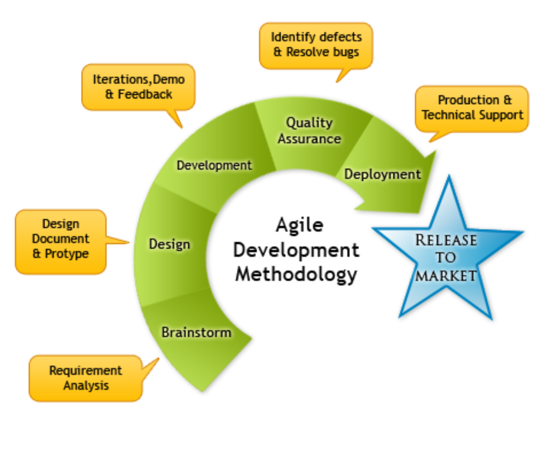Due to the demand in the field of Information Technology, software development must be robust, efficient, and quicker. To achieve the project completion, Agile has been the preferred method to accommodate the demand and time to accomplish the task. The principles of this methodology are: customer satisfaction by delivering valuable software that has the most urgency, this method is adaptable to changes in order to align the changes as per the usual requirements, it is capable to deliver quicker, and lastly Agile promotes sustainable development.

Apart from principles, Agile has several option types to choose from like extreme programming, SCRUM, Crystal, Future Driven Development, LEAN development, and dynamic system development method. SCRUM method will be used for this project. The advantage of SCRUM is it does not specify software development techniques. It focuses on the functionality of the team member to produce outcome in the enchanting environment. It has requirements, time frame, resources, and technology. These are expected to alter during the development. Agile has three phases; the first one is the Pre-phase where planning, architecture and design occur. The second phase is the development phase where sprints are executed. This is the area where sprints are developed. The last phase which is the post phase. It is a phase of implementation. Implementation includes testing, change requests and documentation (Abrahamsson, Salo, Ronkainen, & Warsta, 2002).

Chapter 5: Risks and Limitations

5.1 Risks

5.1.1 System modification

5.1.2 Logic or Time Bomb

5.1.3 Sensitive Data Leakage

5.1.4 User Interface Impersonation

5.2 Limitations

5.1.1 User Friendly Application

The application is designed to be user-friendly for stage 1 Alzheimer’s Disease patients. It might not be appealing to other users but the way it is constructed is based on patient’s situation.

5.1.2 User Manual Guidelines

5.1.3 Compulsion of Internet Connection for data security

Data security will be enhanced when internet connection is available.

5.1.4 Time constraint

Due to time constraint, there are other features that the team would like to include but not likely to happen during this version.

Chapter 6: References

Abrahamsson, P., Salo, O., Ronkainen, J., & Warsta, J. (2002). *Agile Software Development Methods: Review and Analysis.* Finland: Vtt.

Callone, P., Kudlacek, C., Vasilof, B., Manternach, J., & Brumback, R. (2006). *A Caregiver's Guide to Alzheimer's Disease - 300 Tips for Making Life Easier.* New York, United States of America: Demos Medical Publishing, LLC.

Chin, K.-Y., & Tay, S. (2018, July). A Review on the Relationship between Tocotrienol and Alzheimer Disease. *Nutrients, 10*(7), p. 1. doi:10.3390/nu10070881

Dahm, R. (2006, November 7). Alzheimer’s discovery. *Current Biology, 16*(21), pp. R906-R910. doi:doi_10.1016_j.cub.2006.09.056

Weinstein, J. (2018, 1 12). A New Direction for Alzheimer’s Research. *Neural Regeneration Research* , 190-191. doi:10.4103/1673-5374.226381

Fashmel. (2018, september 30). *Dementia/Digital Diary/Clock*. Retrieved from Dementia/Digital Diary/Clock: https://play.google.com/store/apps/details?id=com.fashmel.alzclock

*Memory Helper Carer Assistance Tool*. (2018, october 16). Retrieved from Memory Helper: https://play.google.com/store/apps/details?id=com.memoryhelper

Reis, A. (2018, october 11). *AMOM*. Retrieved from AMOM: https://play.google.com/store/apps/details?id=com.amom

Team, A. M. (2018, OCTOBER 20). Retrieved from ALZHEIMER MASTER : https://play.google.com/store/apps/details?id=amaster4.amaster4